ratproxy 1.51 tutorial
Published
by
dan
on July 5, 2008
in Web
.
Ratproxy is a [mostly] passive web vulnerability scanner that Michal Zalewski released a few days ago. Set ratproxy to proxy your web browser and go surf! When you’re done, run a shell script and out pops a clear report of all the vulnerabilities ratproxy thinks it saw.
I’ve played around with ratproxy the past few days and used it to find vulnerabilities in some major websites. Here is a short cheatsheet I wrote up, an example report file and what it means, and a quick look into the source code of ratproxy.
Cheatsheet:
./ratproxy -v dumpdir -w audit1.log -d host.domain -lextifscgjm
Small set: -lfscm
Big set: -lextifscgjm
Active: -XClfscm
Everything: -XClextifscgjm
When done, run ./ratproxy-report.sh audit1.log > audit1.html
-v folder to save http traces
-w the log file
-d the domain to analyze (multiple -d’s are allowed)
-l relaxed page checksumming
-e check caching
-x XSS candidates (-X disruptive XSS checking)
-t directory traversal candidates
-i log PNG images (possible XSS in IE)
-f log all flash and pass to the decompiler
-s log all POST requests
-c log all URLs that set cookies
-g extend XSRF checks to GET (POST and COOKIE are done by default)
-j detect evil JS functions (eval, innerHTML, etc)
-m remote images/remote linking (breaks when -d is unset)
-X active testing, validate potential XSS, XSRF
-C replay requests with modified params
-k assume HTTPS must always be on, report downgrades to HTTP
-a log all visited URLs (track code coverage)
Ratproxy breaks a trend in the security community in that it isn’t written in Ruby or Python! It’s all written in C and bash. I had no problems getting it to compile on Linux, Mac, and Windows (Cygwin). Ratproxy uses an external library to decompile flash files that you have to replace with the proper one for your platform.Â Note: as much as you are tempted, don’t turn on ratproxy and pump wget through it. As a friend described it, wget will only download the “scrapeface” of the website and will behave in a substantially different manner than a human would, which ratproxy depends on for a few of its checks. Also note: turning on the “-XC” options will let ratproxy make potentially harmful requests on its own. If you’re going for stealth, leave those off and stick with “-lextifscgjm” for the largest set of possible vulnerabilities.
To demonstrate some of ratproxy’s capabilities, I set it up to actively analyze the poly.edu domain:
./ratproxy -v dumps -w poly.log -d poly.edu -XClfscm
Then I set my proxy in Firefox to be localhost:8080 and went to work surfing the web (heh ratproxy will usher in a new age of legitimate excuses for security pros to slack off!). I read some news about the NYU merger, looked up athletics info, found some IT policies, and read about the BEST center. To quit, you just CTRL+C the ratproxy process and set Firefox to connect directly to the web again. The poly.log file should be filled up by now. This log file is a pipe-separated, one-issue-per-line, easy-to-grep report, but right now I just want something easy to read so lets process it into a nice html report:
./ratproxy-report.sh poly.log > poly.html
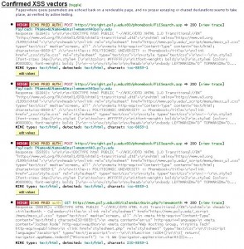
Nice! There are a whole bunch of confirmed XSS vectors right at the top! There doesn’t appear to be anything else too serious, but those are good results considering I did basically nothing for them. It looks like there are two separate pages I went to with XSS, let’s try and verify both. The first is at http://insight.poly.edu/phonebook. Let’s go grab one of RSnake’s XSS locators, put it in a field and see what happens:
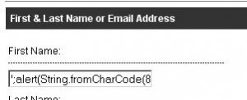
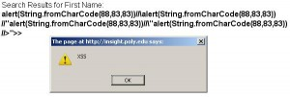
Sweet! Ratproxy knows what it’s talking about. Now let’s try the calendar at http://www.poly.edu/calendar/. According to the report, it looks like the ‘view’ parameter is vulnerable. Let’s just re-use the same XSS locator since it worked so well last time.
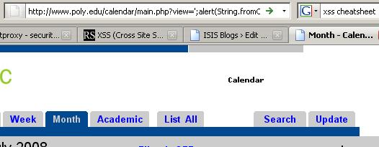
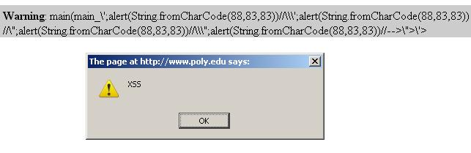
Ratproxy is good at this. Let’s take a look at the code they’re using to “disruptively” check for XSS.
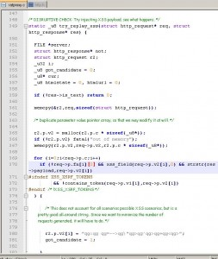
(fyi, http_request.p is a list of decoded parameters) Sticking with their “don’t be evil” mantra, no actual javascript is injected into the web application. Instead, they’re taking all the parameters they’ve already determined are echo’d back and putting in the dummy string qg:qg qg=–>qg\”qg>qg’qg>qg+qg<qg> to check for input validation/output encoding. Later down, starting at about line 440, they have what is basically a huge switch looking for how that string was returned.
My overall assessment of ratproxy is that it’s a good first-pass tool when you’ve got a nice big web app and don’t know where to start. Ratproxy will help you pick out interesting bits to focus on and identify weakly coded chunks of applications within larger websites (notice that ratproxy picked out the phonebook and calendar above, but nothing important was returned on the main Poly website). One thing in particular that I like about ratproxy are its clean and useful reports. Each report starts with a concise description of the issue, whether you can access it pre-auth, an excerpt of the http trace demonstrating the issue, and a link to the full trace. Other web application vulnerabilities scanners need to learn from this!
Keep up the good work Michal!
This work, unless otherwise expressly stated, is licensed under a Creative Commons Attribution 3.0 United States License.
« Cute + Malicious == Deadly
Security Meetup 07/09 Cancelled »

15 Responses to “ratproxy 1.51 tutorial”
Feed for this Entry Trackback Address

- 1 Dan Guido
July 5, 2008 at 2:24 pm
Other people have successfully implemented passive vulnerability scanners before. I remember Jay Beale and Matt Wollenweber both talking about passive traffic analysis to determine vulnerabilities at ShmooCon ‘08. Jay’s implementation was for analyzing your edge traffic for hosts in your network that needed to be patched. Matt’s was for your own machine so you could build up a profile of people you wanted to 0wn. Tenable’s PVS also comes to mind. Ratproxy, however, is the first time I’ve seen it done specifically for web applications.
- 2 PaulM
July 5, 2008 at 5:01 pm
Nice tutorial. Ever tried it with in a crawl, like ‘wget -m’ or something similar?
- 3 Dan Guido
July 5, 2008 at 7:16 pm
From the article:
“Note: as much as you are tempted, donâ€™t turn on ratproxy and pump wget through it. As a friend described it, wget will only download the â€œscrapefaceâ€ of the website and will behave in a substantially different manner than a human would, which ratproxy depends on for a few of its checks.”
The official docs also mention this. Granted, I haven’t tried it myself, but I tend to believe the author.
- 4 Smalldevil
July 9, 2008 at 11:14 am
What is the command to obtain a ratproxy executable ? I have an error during the make.
Thanks.
- 5 phader
July 9, 2008 at 1:33 pm
@Smalldevil:
Ratproxy requires the OpenSSL development libraries. Make sure those are installed on your system before trying to make.
- 6 thefabulous
July 17, 2008 at 8:29 am
What is the error?
- 7 Dan Guido
July 17, 2008 at 5:33 pm
From the manual:
1) Ratproxy can be compiled with make and requires a reasonably configured build environment similar to what is required for any other application. It does not depend on any arcane libraries or non-standard tools; you might have to remove the -Wno-pointer-sign from Makefile on older systems, but that’s about it. If you still need help setting up such an environment and running ratproxy on Windows, there is a nice third-party guide prepared by David Marginian:
http://butterdev.com/web-security/2008/07/google-ratproxy-web-application-security-audit-tool/
http://butterdev.com/dwr/2008/07/google-ratproxy-part-2-running-and-using-ratproxy/
Please be advised, however, that ratproxy is not meant to be a point-and-click tool - if you have a difficulty running it in the first place, you may also have a hard time understanding its output and verifying it.
- 8 funnygirl
August 7, 2008 at 1:04 pm
+100. Respect.
- 9 fengcj
August 19, 2008 at 3:08 am
Hi, I use command:
./ratproxy -v dumps -w mobile.log -d fxtest.bestwiz.cn -lextifscgjm
but when finished, the file size of mobile.log is 0, why?
- 10 Dan Guido
August 19, 2008 at 8:36 am
@fengcj
With that command line, you set up ratproxy to work as a local proxy on port 8080 and to analyze the traffic it receives from fxtest.bestwiz.cn. Did you correctly connect your proxy? Did you browse to the fxtest.bestwiz.cn website?
- 11 fengcj
August 19, 2008 at 10:59 pm
I set my proxy in Firefox to be xxxx.xxxx.xxxx.xxxx:8080,
xxxx.xxxx.xxxx.xxxx is the server where ratproxy was installed.
when I use the command : netstat | grep 8080 on ratproxy server, I can see the connection from me.
- 12 Dan Guido
August 19, 2008 at 11:00 pm
AFAIK ratproxy only listens on localhost.
- 13 fengcj
August 20, 2008 at 1:22 am
Got it ï¼Thanksï¼
- 14 fengcj
August 20, 2008 at 3:31 am
I am sorry for another question: How to make XSS work after html report being built?
- 15 fengcj
August 20, 2008 at 4:24 am
I got the answer, so please ignore this question
- 1 Google’s Free Web Security Assessment Tool | Infosec Events
Pingback on Jul 5th, 2008 at 3:24 pm

